Spanish American War Script June 18, 2011
Items we don’t have yet Notes to Tod
Theme | File | Caption
#1 Media and the message | 18-battleship-maine-1  17-maine-wreck(right half)  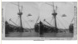 | The Battle ship Maine,  Before and After  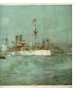 | The mysterious explosion of the Battleship Maine in Havana’s harbor was instrumental in committing American troops to what was to become the Spanish American War.
 | Headline-war-begins 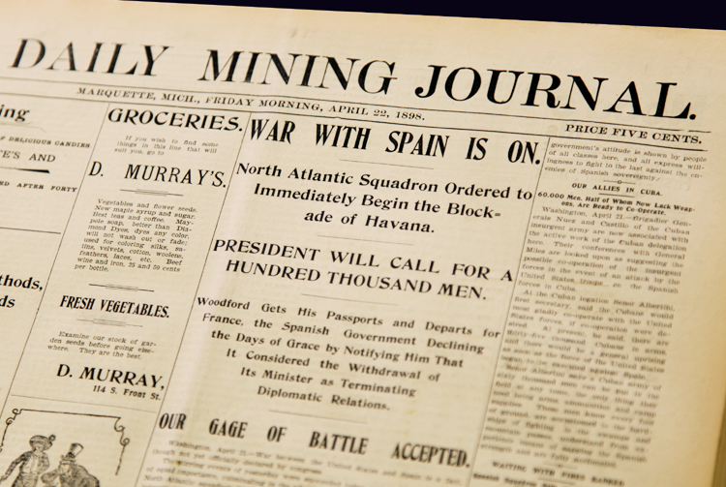  16-burial  stereograph of caskets at Arlington  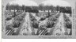 | Burial of victims of the Maine in their final resting place at Arlington Cemetery, VA, 1899 | “Yellow Journalism” had its start in the Spanish American War. Newspapers were the primary source for information in the country at the time. Editors often offered their interpretation of the news over objective journalism. If the facts presented were distorted, the public had few options for fact checking. Flamboyant headlines increased circulation and this irresponsible approach to journalism became know as “yellow journalism.”  William Randolph Hearst and Joseph Pulitzer lead the charge for American involvement in Cuba. Their competing publications reported alleged brutality of the Spanish toward Cuban rebels. By the time the USS Maine exploded in Havana Harbor, the pro-war press made it difficult for President McKinley to make any other choice but to enter the war. His political future rested upon that.
 | Charge-Up-San-Juan-Hill.jpg  15-t-roosevelt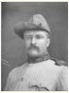 | Fredrick Remington’s ‘Charge Up San Juan Hill’  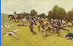 | Frederic Remington, the famous illustrator of the West, was sent to Cuba to supply sketches depicting the Spanish atrocities to Hearst’s New York Journal. Remington remained in Cuba after war was declared. When Theodore Roosevelt led the famous charge up San Juan Hill, Remington documented it.
 | Put the headlines here in order given by my notes. |  | Pulitzer sent the famous author Stephen Crane (The Red Badge of Courage) to cover the war in Cuba.  When war was declared in April of 1898, President McKinley requested funding from Congress to refurbish the armed forces. The size of the army rapidly expanded from 28,000 to 250,000. The following are local headlines which reflect the involvement of Upper Peninsula volunteers in the war effort.
 | 12-marquette-leaving for ...  13-social –life  14-marquette parade  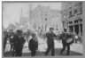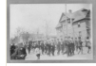 | Local volunteers marching in Marquette before being shipped out for training. | Recruitment Practices  There was no draft for the Spanish American War. Volunteers were recruited easily as this conflict had received much media attention. Samuel Wheeler of Marquette was responsible for recruiting 86 men of Company L who were trained at Camp Alger. Among the first to enlist was Peter Vandenboom and was also Marquette’s first casualty when he died from malarial fever.
 | 11-rough-riders  10-troop1  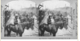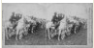 | Roosevelt’s “Rough Riders” arrival in Tampa, FL, USA  Troop 1, 6th US Calvery, Camp Tampa, FL, 1898 | “Rough Riders”  African Americans served in the Navy and Army. Native Americans fought in the war, especially in the First Volunteer Cavalry (Rough Riders) and in the First Territorial Volunteer Infantry. Women served in the U.S. Army Nurse Corps.
 | 09-boarding-transport 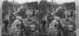  08-fighting-line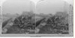 | Boarding the Transport boats for Santiago, Tampa, FL  Fighting line near Pasay – the trenches and lookout guard – Philippine Islands, 1899
 | 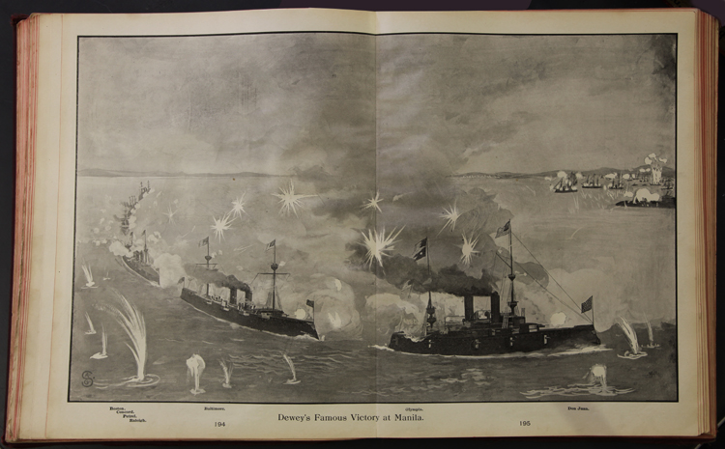img_0079 | Dewey’s victory at Manila Bay, 1898 | Battles at Sea  George Dewey’s resounding victory at Manila Bay destroyed Spain’s naval power in the East and was instrumental in quickly ending the war.
2. Voices of Veterans and Families | Use the letters from the newspapers (will photograph later) |  | Peter Vandenboom  Peter was one of the first recruits for Company L, 34th Regiment Michigan Infantry. The Daily Mining Journal reported that the Company was camped at the foot of San Juan Hill in August of 1898. The article goes on to say that there is “more malaria there than on the hill. The commander of “L” reported that 197 men were sick in his company and 120 in other battalion of 800 men. Scores of men were so weak that they were unable to walk unassisted or even stand up.” Peter Vandenboom died on August 6, 1898 at the age of 18.
 |  |  | The following letter was written in July.
 |  |  | Letters from Joe Thoney, Ned Watson and Peter Grant
 | image??? | (Audio file coming) | Homer Gluck wrote home to Marquette from the war.  Listen to his letter....
 | 06-ishpeming-light-guard  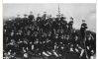05-tommy-beaudry | 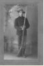 | The following images show Upper Michigan veterans who served in the war.  The Ishpeming Light Guards originally organized in 1898 as a home militia group. They became soldiers for Uncle Sam by May of that year.  Tommy Beaudry, from Marquette, served in the War.
 | Our Boy publication???
#4. Technology and Deciding factors | 07-ss-oregon  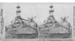 | The battleship  SS Oregon | At the time, national prosperity and power depended on control of the world’s sea lanes. “Whoever rules the waves, rules the world” as naval strategist Alfred Mahan said. The United States began replacing wooden sailing ships with steel or “ironclad” ships powered by coal or oil. This created the need for refueling stations in various regions of the world.
Disease
Disease was an important factor in the Spanish American War. More men died of disease – malaria, typhoid fever, yellow fever- than died of battle injuries during the Spanish American War. The disease total was 500 deaths in Cuba and an additional 250 deaths in Long Island, NY camp where the sick men were treated upon return to the US. Battle deaths were 300 plus 260 men who died during the explosion of the Maine.
Edward C. Watson from Marquette was a volunteer soldier in Cuba during the war. He arrived in Cuba on June 29, 1898. His company “plodded wearily through the intense, insect-thick heat of Cuba’s interior.” These conditions caused the incidence of malaria and dysentery to skyrocket. Food was scarce. The men had little food except fruit they picked up from the ground. Barely two months after the war had been declared, the Spanish stacked their arms in surrender. That night Watson fell sick with malaria and dysentery. His company returned to Marquette early in September 1898, and Watson became dangerously ill and for several days it was touch and go. Fortunately he recovered, but during the next ten years he had recurring bouts of malaria. Out of the original 76 members of his Company L, two men died in Cuba and six died upon return.
 | 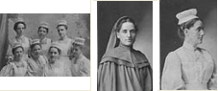  Olive Pendill 1 2 3 | 1) Some of the graduates of St. Lukes Hospital, Chicago, 1898. Miss Pendill- 3rd from left, front row  2) Miss Pendillas a Red Cross Sister, 1897  3) Miss Pendill, St. Lukes Hospital, Chicago, 1897 | Olive Pendill  In 1896, at the age of 30, Olive Pendill of Marquette chose a nursing career. With two years of training in Chicago at St. Luke’s Hospital, she was prepared to serve in Cuba for her idol, Clara Barton, the founder of the American Red Cross. Years later, Olive wrote of her Spanish-American experiences.  “On Christmas morning it mizzled, there was no dry spot, the wind blew, the stove smoked, the rain fell. The cook deserved our sympathy, although all of us nurses felt sorry for ourselves as we ate a cheerless breakfast of black coffee, cold Boston baked beans and hardtack…”  “We were not allowed to leave camp. Havana was quite forbidden. Besides brawls, there were the dread diseases to be feared that might have been brought back to the hospital, such as malaria and typhoid.”  “We hear there are dangue, malaria and typhoid in (other) camps, and, if these be at all severe, they will be brought to us at the Division Hospital.”  “Water is brought four miles in barrels. The well water in the near ravine…is forbidden to us.”  “Just a few feet from the kitchen stood the receptacles for soiled linen and secreta. Is it not a wonder that more than one corpsman did not occupy beds in the wards?”
 |  |  | The harsh environment of tropical Cuba presented great difficulties for the troops as well. Disease was widespread, the heat was stifling, food and supplies were scarce, and flies and mosquitoes were everywhere. As such, cases of malaria and dysentery rose dramatically. The connections between contaminated water and typhoid and between mosquitoes and malaria had not yet been made.
#5 Role of Upper Michigan | 2 Newspaper headlines here – Ishpeming people collect clothes and Escanaba Raising $ for Comp L |  | The short duration of the war did not demand an increase in iron ore and copper production. There were also no fears than an enemy might sabotage shipping in Lake Superior.  Living conditions in Cuba and the other areas affected by the war were miserable for the local boys of Company L. When letters began arriving from the front, local individuals began fundraising for the soldiers. Lawn socials were held and chain letters were sent to raise dollars for the effort. At the same time, Ishpeming people began collecting clothes and others prepared relief “care” packages to be sent to local boys. By the time the local effort was organized and packages were sent, the war was nearly over.
#6 Arrival Home | Headline- Gala parade |  | Throngs of people turned out in the cities of the Upper Peninsula to welcome veterans home. The brief and successful war made citizens proud of their hometown boys who served in the war.
 | 03-social-life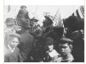  04-marquette-carriage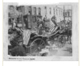 | (On second photo)  One carriage remained empty to mark those who did not return, including Peter Vandenboom and Joseph Berry. | “Queen City Went Wild With Joy”  Half the town of Marquette came out to greet the returning soldiers from the Spanish-American War in 1898. Over one hundred soldiers of Company L were met at the train station, and a parade wound its way through town with music and clanging bells.
Caring for Veterans and Family after War
After returning home, Spanish American veterans could apply for a pension from the federal government. The veterans’ assistance program was expanded to include benefits and pensions not only to veterans but also their widows and dependents. Soldiers killed in battle as well as veterans who had served their country were eligible for burial in a federal or nationally funded cemetery.

At the turn of the century the pension program reached almost half the federal spending budget. This is due to veterans and widows living longer and an increase in fraudulent claims. As a result, legislation was put in place that required individuals to provide evidence directly connecting war service to disability or illness. This was especially difficult for veterans whose disabilities were a result of exposure to an unfamiliar disease, new environmental hazards and the emotional trauma of battle. Their symptoms didn’t present themselves until years later, making it difficult to find evidence required to claim benefits.
 | Lambert-troop  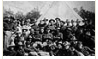  Lambert-camp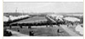  Lambert-Joseph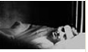  Lambert-children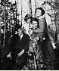 | (Tod: this story is three rows of text. You probably need 2-3 screens, say ‘continued’ at end and beginning) | Clara’s Story – Part 1 of 3  Clara Lambert’s husband, Joseph, died of pulmonary tuberculosis in 1921 at Morgan Heights hospital in Negaunee, Michigan. A veteran of the Spanish American War, Joseph believed his illness was caused by exposure to malaria during his service in Cuba. Born 1877 in Quebec Canada, Joseph Lambert immigrated to Ironwood, Michigan. He was not yet an American citizen when he joined the Michigan National Guard. He served in Cuba with Co. E. 34th Regiment Michigan Infantry. Upon his return home, he was treated for “malarial poisoning” by a local doctor yet he never fully regained his health. In 1916, he moved to Marquette, Michigan with his wife and three young children. A trained mason, Joseph had difficulty earning a living after the war due to chronic health issues.  He left his widowed wife Clara and three children with a large debt and no property of value. Clara’s widow’s pension provided $12 a month and $2 for each child. In order to secure a higher monthly benefit, she needed to prove her husband’s disease was caused by his exposure to malaria years earlier.
 | Clara-lambert-letter  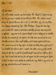 | Letter – Clara Lambert request affidavit on behalf of husband  Date May 17, 1922  To: Dr. Gilles Leblanc  From: Clara Lambert | Clara’s Story – continued  Clara Lambert wrote countless letters trying to prove her husband’s case.
 |  | (Tod – parchment pic is included if you want to use it as a background) | Clara’s Story – continued  Affidavit – stating financial status of Clara M. Lambert  Date June 24, 1921  To: Widow’s Division  From: Father Jodacy Pastor of St. John’s Church and Alice M. La Londe, Marquette  Excerpt: That Clara has no real or personal property of value. Except sum of one thousand dollars death benefit from Knights of Columbus, was required to pay over two hundred dollars of debt from this money., no fixed income, keeps boarders which she receives fifteen dollars monthly. With this income she supports herself and three children. Has no income for clothes for herself and children.
From Manual of Laws, Relating to Pensions

Pension is granted by the general laws to all persons disabled by reason of any wound or injury received or disease contracted in line of duty while in the military or naval service of the United States at any time.

The disability resulting from disease there are five general grades of pension per month, as follows: Rate varies with rank from $8-$30.

Specific Rates for disabilities
Loss of both hands $100.00
Total disability in both hands; loss of both feet; loss of both eyes; loss of one eye, if the other was lost before enlistment $72.00
Total disability of arm or leg; loss of one hand and foot; total disability in one hand and foot; amputation at or above elbow or knee. $36
Loss of hand or foot; total disability of one hand or one foot; total deafness $30
For disability requiring the regular aid and attendance of another person…. $72
For disability requiring the frequent but not regular attendance of another person…. $50
For total inability to perform any manual labor…$30
 | 01-clubs-groups  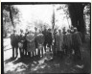 | Marquette area members of the Spanish American War Veterans Samuel Wheeler Post #37 in 1929 at Park Cemetery. Wheeler was responsible for recruiting most of the local veterans in Company L. | Veterans’ Organizations  Soon after the war ended, discharged veterans quickly formed fraternal societies. At the turn of the century many of these societies merged. The three largest groups, the Spanish War Veterans, the Spanish American War Veterans and the Servicemen of the Spanish War formed the United Spanish War Veterans. Eventually this organization included soldiers who had served in the Philippine American War as well.

